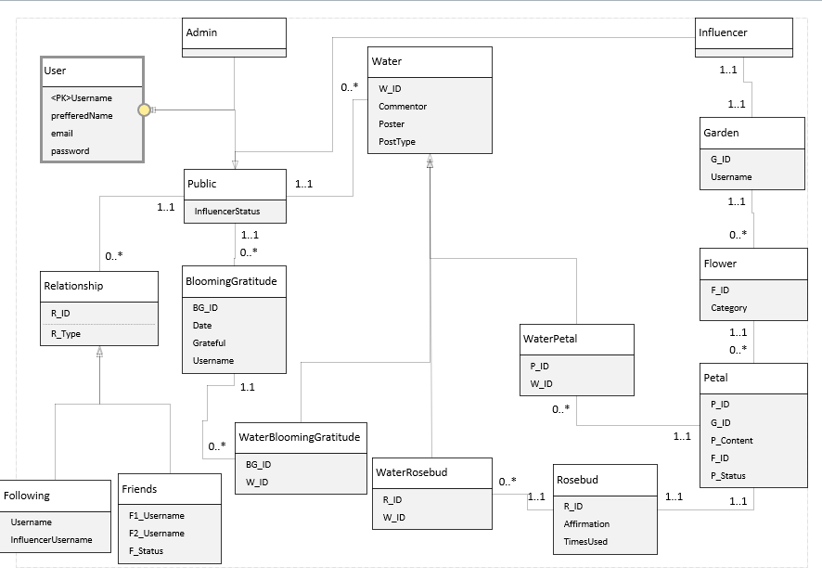

Notes:

* Rosebuds and Petals are independent of each other regarding watering, so if someone waters a Rosebud, this is not reflected on the original Petal that the Rosebud comes from and if someone waters a Petal that is later posted as a Rosebud, these comments are not reflected on the Rosebud.
* The status such as in P_Status, F_Status, and InfluencerStatus, shows the status of an application or request. So the value would either be pending, accepted or rejected. In the case of influencer status in the Public entity, this value would be null if the user has not applied to be an influencer.
* After a certain amount of time, all the rows that have a status of “Reject” will be deleted from the table. This is only stored long enough for the user to be able to view the outcome.
* Once a Petal has the status “Accept”, it is added to the Rosebud table.
* If a user has not answered Blooming Gratitude in a while, they will only be able to view the last Blooming Gratitude of their friends that was available to them for 48 hours, after that there will not be any Blooming Gratitude of Friends displayed until the user has posted a new Blooming Gratitude.

### Terminology

* **Rosebud:** The daily positive affirmation the system shares with the user.
* **Blooming Gratitude:** The daily prompt issued by the system for a user to share what they are grateful for or happy about on that day.
* **Garden:** The page of an influencer which contains everything they have posted.
* **Flower:** A category of posts that an influencer has in their Garden. For example, a Friendship Flower that consists of all the influencer’s posts about friendship.
* **Petal:** The individual posts that make up a Flower i.e., belonging to a specific category, so Friendship Petals will make up a Friendship Flower.
* **Water:** The comment or reaction that a user leaves on a post, such as Rosebuds and Petals.